2019 口試 Breast, Skin, Benign disease, Palliative Oncology
下面內容大量摘錄自RadOncReview網站整理 (https://www.radoncreview.org/)，建議點入細看

Breast – 高長黃英彥主任Case-based discussion

Case 1 65 y/o female, newly diagnosed left breast cancer, cIMN+(?), s/p BCS & AxLND, pathology: primary tumor size 5cm, LN(6+/10)
Ask: staging and subsequent managements
Ans:
1. Staging: (based on AJCC 8 anatomical staging … prognostic staging請查表QQ)
a. T stage T2(>20 ~ ≤50 mm in greatest dimension)
b. Clinical N stage
- if clinically palpable axillary I/II LN only = movable/fixed cN1/N2a
- if clinically detected IMN without axillary LN = cN2b
- if clinically both axillary & IMN = cN3b
c. Pathological N stage (SLNB 🡪 ALND; AJCC … in most cases, lymph node dissection of Level I and Level II of the axilla includes 10 or more lymph nodes; NCCN consider no further axillary surgery per ASCSOG Z0011 criteria – meets ALL T1/2, 1 or 2 SLNs, BCS, WBRT planned, & no NACT; NCCN … axillary staging may be considered optional in particularly favorable tumors, +/- adjuvant Tx, elderly, serious comorbid …)
- patient 6+ axillary LN, if no clinically IMN = pN2a
- patient 6+ axillary LN, if clinically IMN (by imaging) or sentinel IMN biopsy (+) = pN3b
2. Managements: (systematic chemotherapy first 🡪 RT)
a. NCCN suggest systematic adjuvant treatments based on HR and HER-2 status
- Due to pT2N3b disease 🡪 adjuvant chemotherapy +/- anti-HER-2 +/- endocrine therapy (consider omit in favorable histology --- adenoid cystic and other salivary carcinomas, secretory carcinoma, rare low-grade forms of metaplastic carcinoma)
b. Locoregional treatment after BCS
- It is common for RT to follow chemotherapy when chemotherapy is indicated
- Adjuvant HER2-targeted therapy +/- endocrine therapy may be delivered concurrently with RT, while capecitabine should follow completion of RT
- WBRT +/- tumor bed boost + regional nodal irradiation(RNI)
- WBRT with 45-50.4Gy in 25-28fx, a boost to the tumor bed is considered per EORTC 22881 (improve IBTR, esp. ≤40 y/o, but increase severe fibrosis; same OS; old trial without concern effect of modern systematic treatments, standardize margin, RT technique, molecular heterogeneity…), typical doses 10-16Gy in 4-8fx
- RNI to supraclavicular/infraclavicular, internal mammary nodes (1-3 intercostal space) and any part of the axillary bed at risk per MA.20 (improve DFS with more Gr.2+ pneumonitis & lymphedema), EORTC 22922 (improve any breast REC and BCM), DBCG-IMN (+IMN improve OS, BCM, DM)
- A supplemental boost of RT can be delivered to grossly involved or enlarged LNs that have not been surgically addressed (no IMN dissection) … similar to tumor bed boost dose, or even higher to 66Gy (adjusted by size?) with respect of OAR constrain or advanced technique use (breath control, daily image, position, proton…)
- OARs (per NSABP-B51): ipsilateral lung V20<35%(40%), V10<65%, V5<75%; contralateral lung V5<15%; contralateral breast V3<10%(V5<10%); heart D_{mean} ≤4Gy(5Gy), V25(V30)<10%(left breast), V25(V30)<2%(right breast)

Case 2 43 y/o female, newly diagnosed left breast cancer, 3cm 🡪 BCS, due to occupation concern(長期在海外工作，最多只能停留台灣一個月), surgeon suggest IORT

Ask: for 2nd opinion consultation, IORT or hypofractionation WBRT
Ans: 題目病人年紀與腫瘤大小不知道合理不合理，這樣年輕腫瘤又偏大，就算勉強做IORT/ABPI，其實也會被抓去打adjuvant chemotherapy (除非HR(+)HER2(-)加上基因檢測說不用化療)。這樣讓她真的省得了時間嗎?
ASTRO 2017 APBI consensus
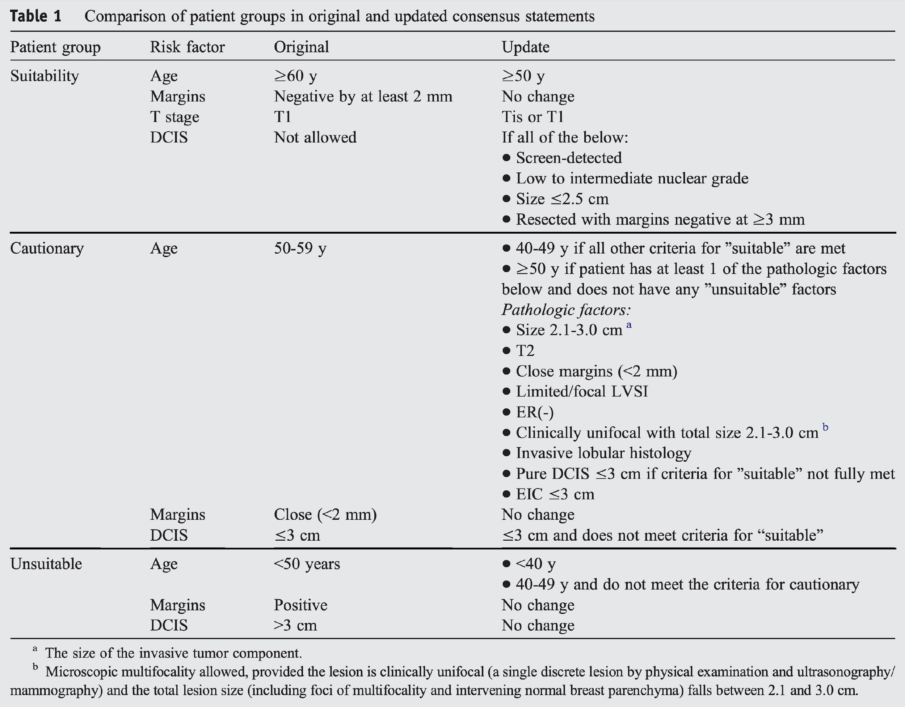
Consensus full-Text裡面他是分成Patient Factors (age, BRCA1/2 mutation)，Pathologic factors (Tumor size, T stage, Margins, Grade(Any), LVSI, ER status, Multicentricity, Multifocality, Histology, Pure DCIS, EIC, Associated LCIS)，Nodal factors (N stage, Nodal surgery)，Treatment factors (Neoadjuvant therapy)下去區分suitable / cautionary / unsuitable，但是搞得有點複雜，我先放上Executive
Summary給大家參考，據說每個細項最好都要背出來(老師會數)

2020 ESTRO IOERT recommendations
Literature data points out that careful patient selection for IOERT as APBI is mandatory. The selection is a two-step process, consisting in a preoperative and intraoperative phase…
- Pre-treatment investigations
– Physical examination (breast size, tumor extent and location) 🡪 excluding multicentricity
– Mammography
– Breast ultrasound
– Biopsy for histological examination & biological tumor features for clinical staging
Additional investigations (optional)
– Magnetic Resonance Imaging (MRI)
== Proper selection for APBI must be discussed in a multidisciplinary context, considering also patients’ age and comorbidities ==
- Intraoperative histologic assessment by frozen section
– Sentinel node biopsy (negative now considered a pre-requisite for IOERT)
– Tumor size
– Surgical margin width
Intraoperative technical aspects
– Technical feasibility of IOERT (sufficient residual breast tissue)
- Postoperative histological assessment
– Surgical margin width
– Histology
– Tumor size
– Lymph node assessment

** Eligibility criteria – Criteria according to APBI guidelines:
- age 50 years; ductal and other favorable histologies; unicentric and unifocal; positive receptor status; pN0 (i-/i+)
** To integrate with – Criteria according to ASTRO/GEC-ESTRO criteria:
- grade 1/2; tumor size ≤2 cm; Luminal A.
IORT Evidence
- Issues with IORT: Final pathology may affect desire to cover nodes. The use of WBRT confounded some trials. Patients who require adjuvant WBRT have added toxicity and added cost. As a result, IORT is recommended only when patients are enrolled on a prospective trial or registry.
Alternative solutions (10y F/U): [Florence] 30/5 PBI or [UK FAST] 28.5/5 q1w WBRT (high tangents for nodal coverage is possible).
- Two types: Electrons (Milan) and spherical applicator with photons (TARGIT)
  - Electrons: 21 Gy to 1-2 cm around the cavity. 6-8 MeV electrons. 5-8 cm diameter cones for treatment. Added lead shield under mobilized breast to protect chest wall.
  - Photons: Uses a spherical applicator with a point source of 50 kV x-rays. Delivers 20 Gy at surface, ~5-7 Gy at depth of 1 cm.
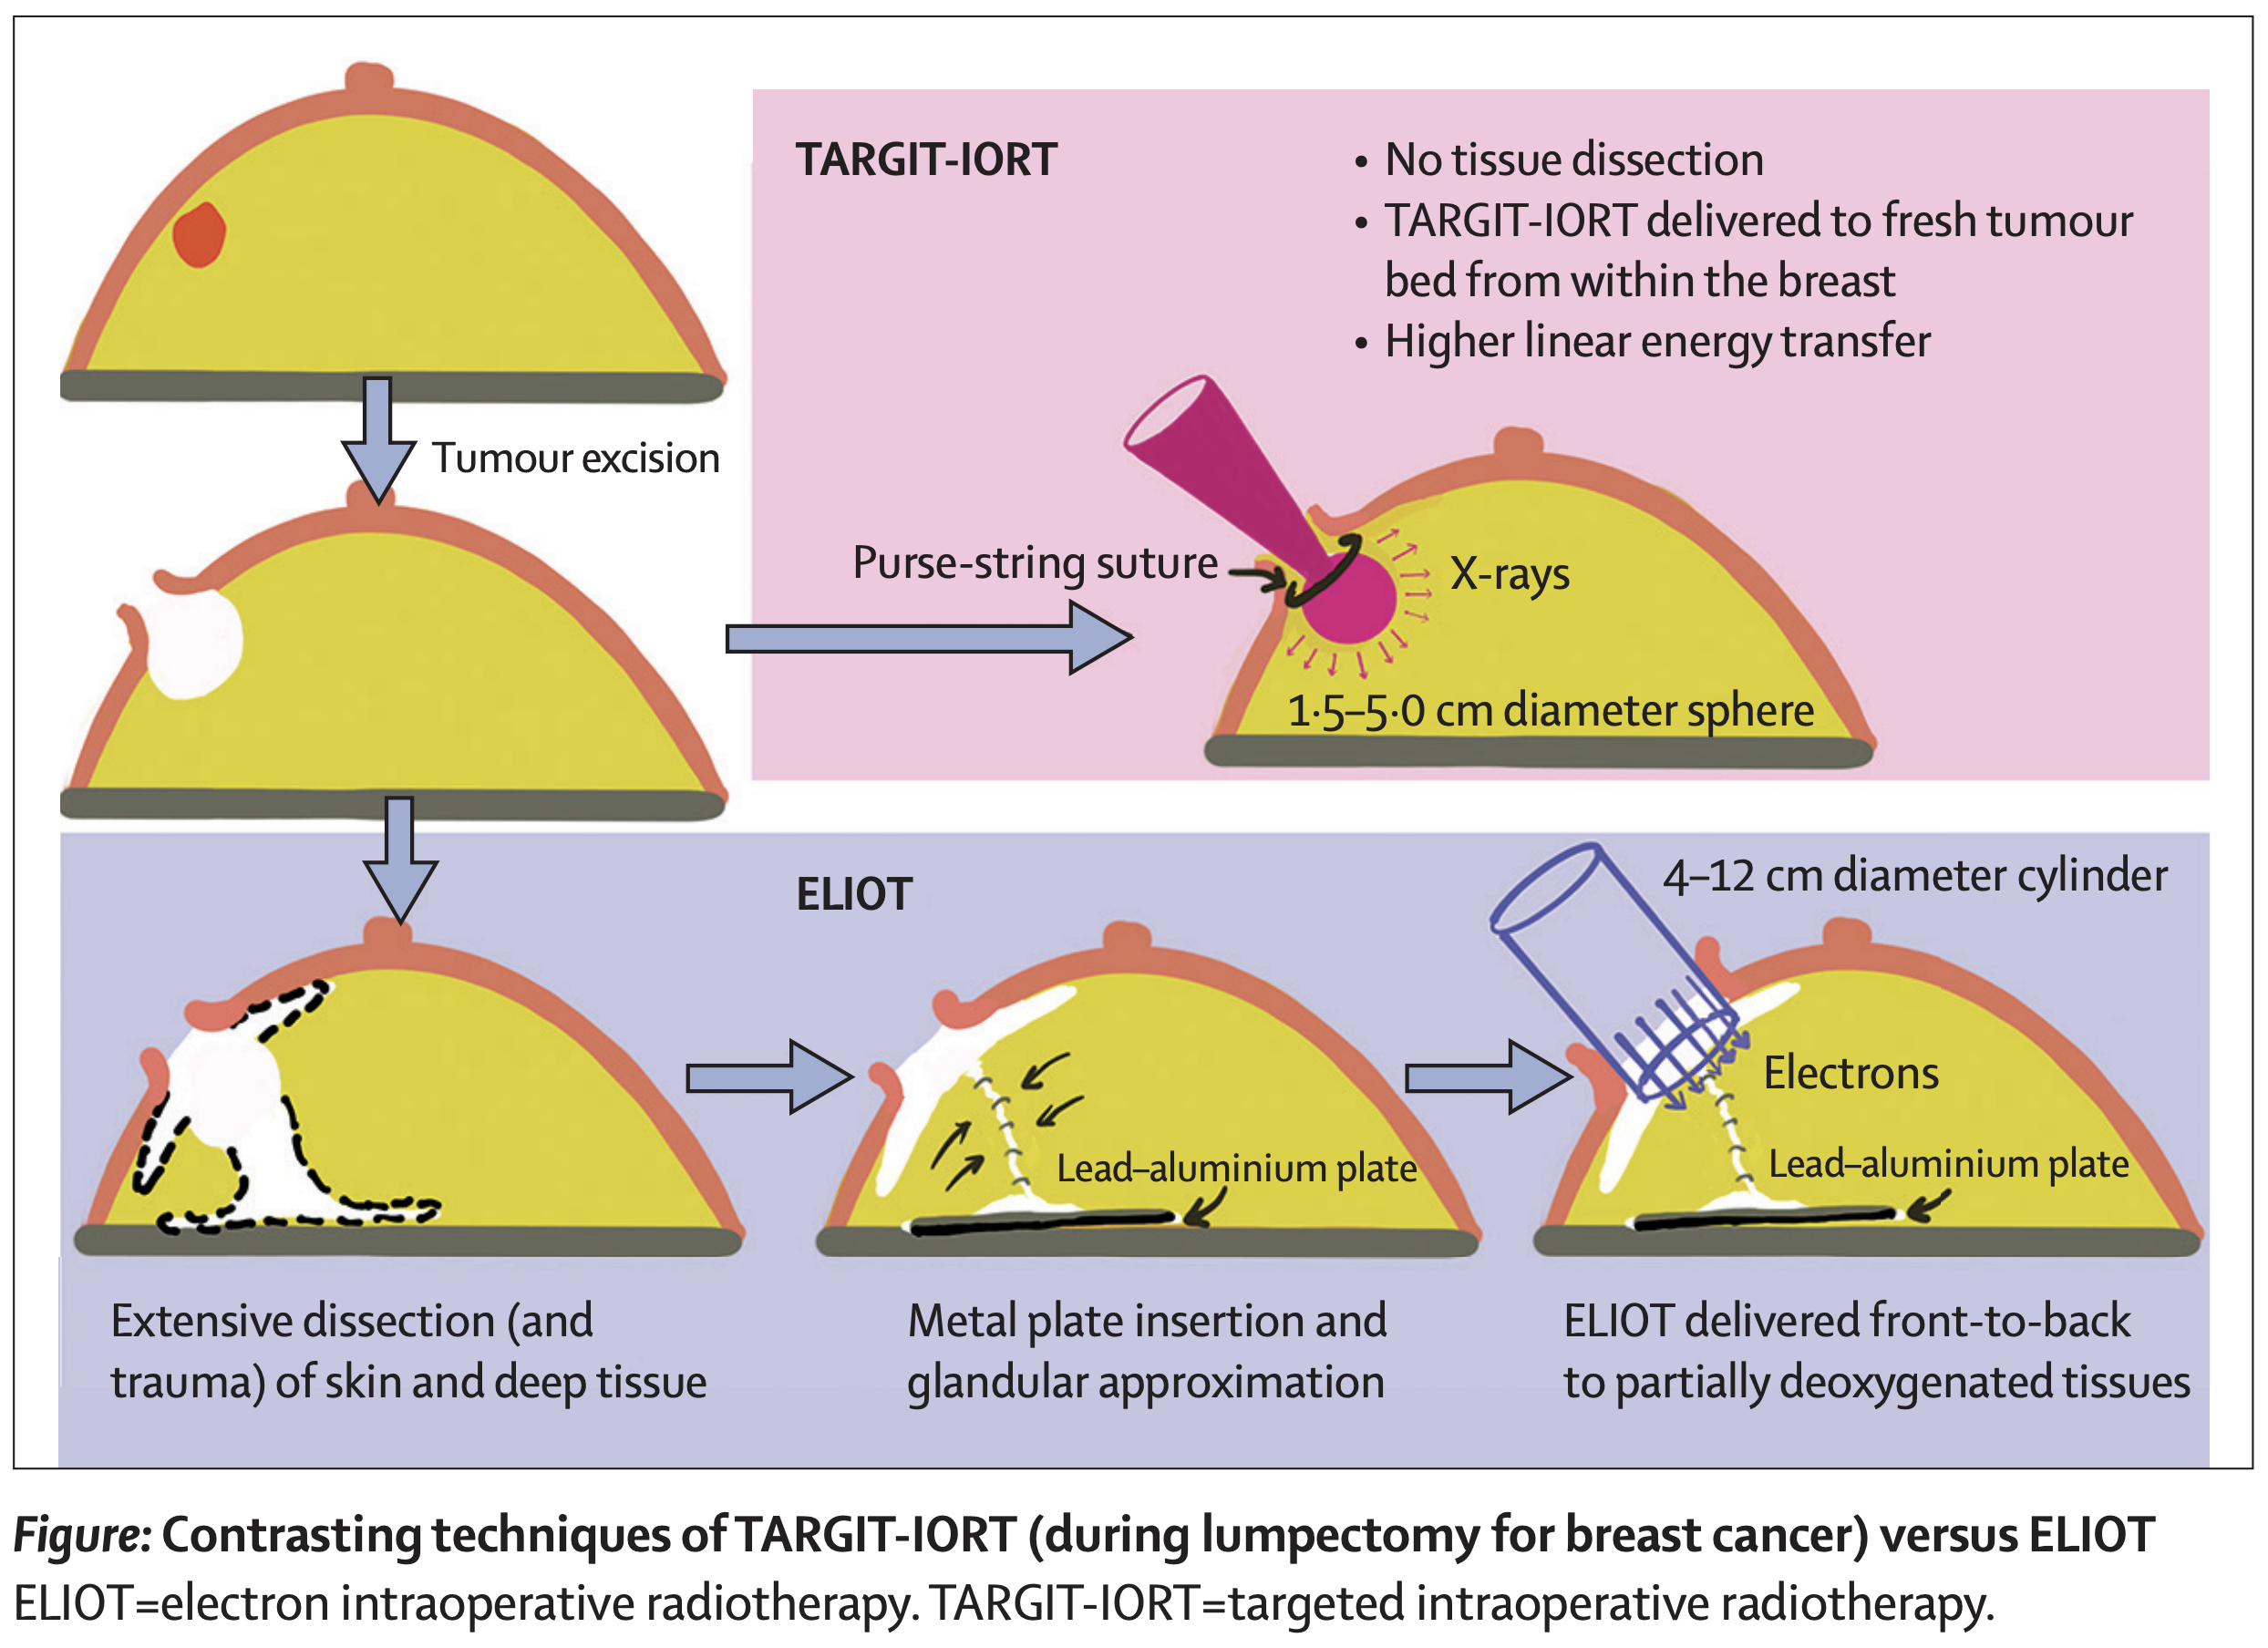
- Milan ELIOT (2000-2007) [Veronesi Lancet '13, Orecchia Lanc Onc '21]: Non-inferior. 50 + 10 Gy vs. 21/1 eIORT.
- ELIOT did NOT have WBRT on eIORT arm, unlike TARGIT-A which was confounded by WBRT. When analyzed as per "suitable" criteria by ASTRO consensus, 5y IBTR was only 1.5%.
TBL ^{QS}: Over 10+ years, the risk of breast tumor recurrence and nodal recurrence is significantly higher with IORT than whole breast RT, although there is no apparent difference in the risk of metastasis or death.
- 1305 pts. 48-75y. < 2.5 cm. 90% ER+. N1 in 21% (final path unknown). MFU 12y.
- 21 Gy to 1-2 cm around the cavity. 6-8 MeV electrons. 5-8 cm diameter cones for treatment. Added lead shield under mobilized breast to protect chest wall.
- Non-inferiority margin of 7%. Compare to 2.5% in TARGIT-A.
- 5y IBTR 0.4→ 4.4%. 5y regional nodal 0.3→ 1%. 5y OS ~97%. 10y OS ~92%.
- 5y IBTR for ± any factor (T2, N2, G3, TNBC) of 1.5→ 11.3%.
- 5y IBTR for suitable / cautionary / unsuitable of 2→ 6→ 13%.
- 15y IBRT for suitable / cautionary / unsuitable of ~6→ 9→ 14%.
- Factors related to IBTR: T2, ER-, G3, TNBC.
- 10y IBTR 1→ 8% (HR 4.62).
- Of recurrences: IFF 40%, OOF failures 60%.
- ELIOT by ASTRO consensus [Leonardi IJROBP '11]: Retro.
Suitable candidates may be acceptable for IORT.
- Suitable: Stage 1, ER(+), > 60y, SM-.
- 5y IBTR for suitable / cautionary / unsuitable of 1.5→ 4.4→ 8.8%.
- 5y CSS for suitable / cautionary / unsuitable of 99→ 99→ 97%.
- TARGIT-A (2000-2012) [Vaidya Lancet '14, JAMA Onc '20, BMJ '20]: Non-inferiority. 40-56 ± 10-16 Gy vs. 20/1 IORT.
- Patients who received IORT as a second procedure had worse IBTR. Therefore, TARGIT-IORT should be used during initial lumpectomy. WBRT was delivered at discretion in ~20% of the initial lumpectomy IORT arm. This group refuses to report long term local recurrence data, instead reporting LRFS where differences in OS may confound results.
- New clinical and biological insights from TARGIT-A during lumpectomy cohort [Vaidya BJC '21]: WBRT calculator 🔮 https://targit.org.uk/addrt
TBL ^{QS}: Despite showing a relatively low rate of recurrence with IORT, TARGIT-A shows how the loss of perceived objectivity by the academic community can permanently affect the interpretation of trial results.
TBL ^{QS}: “A single large dose of radiation such as TARGIT-IORT given during the trauma of surgery might possibly have an abscopal effect... Strange as it may seem, such an abscopal effect appears to give long-term protection against deaths from cardiovascular causes and other cancers.” End scene.
- 3,451 patients ≥ 45y. Most T1 (80%), G1/2/3, ER+/-, pN0/1. Patients were randomized either before their cancer excision (i.e., pre-pathology) or after cancer excision (i.e., post-pathology or Delayed IORT). MFU 8.6y.
- 15% of patients received WBRT: "Risk adapted approach" - required to have WBRT if SM <1 mm, EIS(extensive intraductal spreading/component), or unexpected LCIS/ILC. Individual institutions are also allowed to pre-specify additional factors. (eg, grade 3, node involvement, lymphovascular invasion)
- WBRT was delivered in 21% of the pre-pathology arm, while only 4% of the post-pathology arm.
- INTRABEAM uses a spherical applicator with a point source of 50 kV x-rays. Delivers 20 Gy at surface, ~5-7 Gy at depth of 1 cm.
- Non-inferiority margin of 2.5%.
- 5y IBTR for WBRT / TARGIT-IORT during initial lumpectomy of ~1.0→ 2.1%, confirmed to be non-inferior.
- 5y IBTR for WBRT / TARGIT-IORT during second procedure of ~1→ 4% (p=0.07), NOT non-inferior.
- Median TT delayed-IORT of 37 days after first excision.
- Non-breast cancer deaths of 3.5→ 1.4%, attributable to fewer deaths from CV causes and other cancers.
**延伸閱讀APBI and IORT: Reducing the Burden of Effective Breast Conservation [White, Thompson and Whelan JCO '20].**
我們家(彰基)是在IORT完以後如果permanent margin close or N(+)會再叫回來做external beam RT……如果不想IORT，那3-4週療程的Hypofractionation WBRT，甚至是1週的Ultrahypofractionation WBRT或是external beam/brachytherapy APBI也可以考慮。Hypofractionation WBRT門檻比較低(ASTRO建議如果沒有要照射淋巴區，應該要是WBRT的SoC…現在健保也有給付)。使用APBI條件其實就跟IORT一樣。

Hypofractionation WBRT indication (ASTRO 2018 guidelines), NO RNI
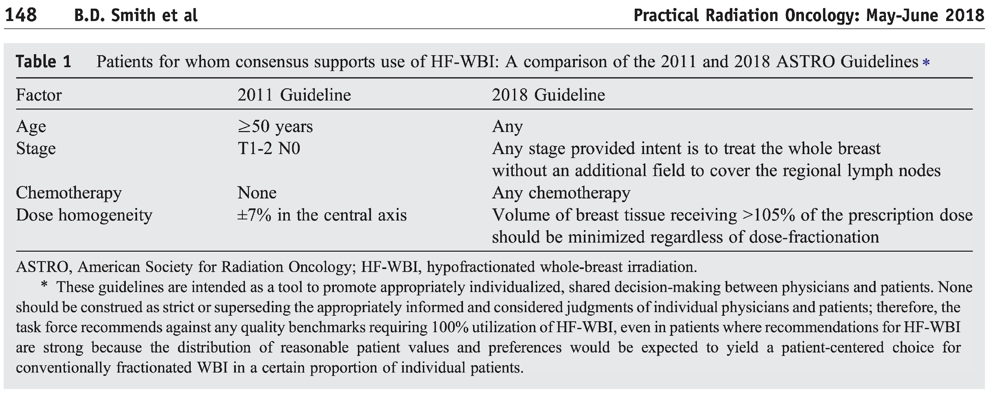
Evidence
- RMH/GOC (1986-1998) [Yarnold RTO '05, Owen Lancet Onc '06]: 50/25 vs. 39/13 (3 Gy) vs. 42.9/13 (3.33 Gy). Estimated α/β of 4 for tumor control, and an α/β of 3 for late normal tissue changes.
- 1410 pts. T1-3 N0-1. 30% < 50y. 14% chemo, 75% boost.
- 10y IBTR 12→ 15→ 9.6%.
- OCOG (1993-96) [Whelan NEJM '10, QoL Arsenault IJROBP '20]: BCS. WBRT 50/25 vs. 42.56/16 (2.66 Gy). No boost.
TBL (bottom line) ^{QS}: In case you needed more evidence, HF-WBI results in less acute toxicity and improved QOL in the Canadian HF-WBI trial.
Hypofractionation is non-inferior to conventional RT with equivalent 10y LR, DFS, OS.
Hypofractionation is now standard if no nodal coverage is indicated.
Do not omit boost if G3 due to long term follow up (START utilized boost, and did not find increased LR with G3).
- 1234 favorable pts. BCS, LN- by ALND, SM-, T1-2 (80% T1), 75% G1-2, 71% ER+, 90% considered for HT. 11% chemo (mainly CMF). Breast width ≤ 25 cm, no multicentric. 25% < 50y. MFU 12y.
- RT: Limit to 107% hotspot. No boost.
- 5y LR ~3%.
- 10y LR ~6.5%. 10y LR for G3 of 5→ 16%. This finding was not replicated in Start A/B.
--- LR for T1 / T2 of 1-2→ 6.4%, so prefer to do it in T1 patients, not T2 ---
- Equivalent cosmesis with ~70% of patients reporting good/excellent outcomes.
- Acute toxicity was similar between groups, but less with hypofractionation at 6-8 weeks. QoL at 6 weeks from start of RT was improved with hypofractionation for skin and breast AE, fatigue, attractiveness, and convenience.
- UK START (1998-2002) [Haviland Lancet '13]: BCS/MRM→ 50/25 vs. Hypofractionation. (The UK Standardisation of Breast Radiotherapy (START))
START A: Higher risk pts, not true accelerated! Unlike NCIC: pN+, boost OK, some MRM. Start A / B: RNI 14→7 %, BCT 85→ 92%, MRM 15→ 8%, boost ~60%, CTX (chemotherapy) 35→ 22%, T1a-b 3→ 14%.
Hypofractionation results in favorable outcomes with low toxicity compared to conventional RT.
There is no suggestion of worse outcome in G3 tumors (as in Whelan), but boost was allowed. Sub-analysis demonstrated favorable outcomes in node positive disease.
- Estimated α/β of 3.5 for tumor control and 3.5 for late breast appearance change (versus 2.4 on [UK FAST]).
- UK FAST Forward estimated α/β of 3.7 for tumor control and 3 for late breast appearance change.
- Any age. Allowed up to IIIA (T3N1) but majority T1-2, SM-, chemo OK (~1/3). Like Canadian, ~20% of pts < 50y.
- 5y arm/shoulder pain 24-32%, 5y difficulty raising arm or shoulder stiffness 10-27% [Haviland RTO '18].
START A (1998-2002): 50/25 vs. 41.6/13 vs. 39/13 over 5w (NOT true accelerated).
- 2,236 pts. 10/5 boost allowed. Higher risk patients. Not true acceleration. MFU 9y.
- 10y LRR: ~5% although 39/13 numbers slightly numerically worse.
START B (1999-2001): 50/25 vs. 40/15 (2.67 Gy; QD, TRUE accelerated). Issue: DM and OM was worse with the 50/25 arm, and it is unclear as to why.
- 2,200 pts. 10/5 boost allowed. Lower risk patients. True acceleration. MFU 9y.
- 10y LRR ~2%.
- Cosmetic outcomes best in 40/15: 77% with good cosmetic outcomes.
  - Less breast shrinkage, breast edema, telangiectasia.
  - In the group that received RNI, there was no difference in arm, shoulder, lung, or heart toxicity.
- 10y DM 16→ 10%, 10y OM 19→ 16%.
- Results suggest the advantage of hypofractionation may be more pronounced in post-menopausal women and medium breast size.
我覺得上面三個trial一定要記起來，至於一些最近的hypofractionation trial主要focus在toxicity (ie. MDACC 🡪 acute QoL/late cosmetic outcome; DBCG-HYPO 🡪 breast induration…)。下面放上一個對岸的文章(華人資料)或許也可參考…
- CH-BC-013 (2010-2015) [Wang JCO '20]: Phase III. BCS→ (50/25 + 10/5 boost) vs. (43.5/15 + 8.7/3 boost) (2.9 Gy).
TBL ^{QS}: Hypofractionated whole breast radiation with boost has similar treatment outcomes and less skin toxicity than conventionally fractionated radiation in Asian women early stage breast cancer.
- 734 patients. T1-2N0-3. WBI ± RNI (< 5%), followed by tumor bed boost. More than 80% T1, N0, ER+. MFU 6y.
- 5y LR ~2→ 1.2%. 5y LRR ~3.5%.
- 3y adverse cosmetic outcome ~10%.
- G2-3 acute skin toxicity ~7→ 3%.

至於ultra-hypofractionation，FAST (10 years)跟FAST Forward (5 years)或許是在跟病人SDM完以後的一個選擇，缺點可能還是FAST Forward follow-up時間不夠長，而且現在只有一篇完整phase 3證據支持…還是選擇IORT以外其他方式的APBI或許會證據力多一點?
Case 3

38 y/o female, left breast cancer s/p MRM in 2 years ago, pT2N0, s/p adjuvant chemotherapy 🡪 Now chest wall relapse, patient refuse surgical excision
Ask: no operation managements, salvage RT field/dose, how to reduce heart dose

Ans: 討論salvage surgery(堅持不開刀)和salvage RT(劑量,範圍,技術)
據說重點是要說出安排re-staging work-up (PE/image/marker…)，確定現在disease status 🡪 if only chest wall relapse 🡪 鼓勵局部切除後再來加上comprehensive locoregional treatment and systemic therapy = 最好outcome (might potentially be cured)
(Ref.台大在IJROBP上有回朔性資料探討此情境; PMID: 18692329)

NTUH分析結果建議在這類post mastectomy patients with isolated locoregional recurrence (ILRR)，劑量most frequently at least 50 Gy，照射範圍建議entire-field radiotherapy (chest wall, supra-/infraclavicular region, axilla, internal mammary region)，技術上面因為患者沒有接受過PMRT，可以採用PMRT之技術執行(tangential photon beams or en face electron beams + single anterior field or the opposed AP/PA fields to lymphatic regions，或是使用3DCRT/IMRT/VMAT計畫，constrain可以採用case 1所建議)
- 結論multivariate analysis revealed that positive axillary lymph nodes, Grade III tumor, negative estrogen and progesterone receptor status at primary diagnosis, disease-free interval of less than 2 years, and less comprehensive locoregional treatment were significantly associated with worse IDFS and OS…
至於想要進一步降低心臟劑量，breath hold /gating techniques (voluntary deep-inspiration breath hold (vDIBH) or active breathing co-ordinator (ABC)), decubitus or prone position, MRgRT (reduce PTV), proton therapy…都是可行的方式

(PS.)目前NCCN對於PMRT indication 🡪 tumor >5cm, margin <1mm = consider PMRT +/- RNI; pN1a(1-3LN), involved margin no re-OP = strongly consider PMRT +/- RNI
ASTRO 2016 PMRT guideline建議可以“consider”考慮下面幾個層面
- Patient characteristics (age > 40 to 45 years, limited life expectancy because of older age or comorbidities, or coexisting conditions that might increase the risk of complications)
- Pathologic findings associated with a lower tumor burden (eg, T1 tumor size, absence of lymphovascular invasion, presence of only a single positive node and/or small size of nodal metastases, or substantial response to neoadjuvant systematic therapy)
- Biologic characteristics of the cancer associated with better outcomes and survival
- Greater effectiveness of systemic therapy (eg, low tumor grade or strong hormonal sensitivity)
另外EORTC 22922有收錄23.9%病人接受mastectomy，其中除了N(+)以外，要是患者centrally/medial quadrants irrespective of axillary involvement，其實也是建議要做chest wall + IM-MS + undissected axilla irradiation (雖然subgroup analysis手術方式只有lumpectomy加上IM-MS irradiation有benefit統計意義…)

最後附上5th ESO-ESMO international consensus guidelines for advanced
breast cancer (ABC 5)給大家參考
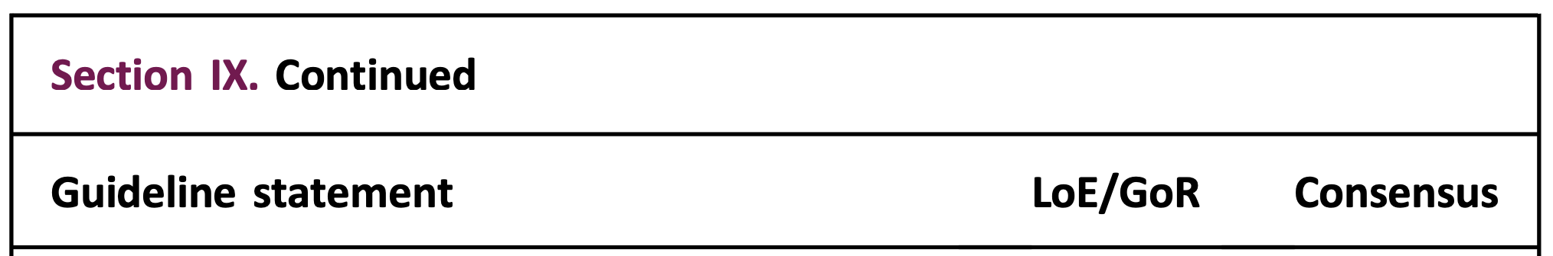
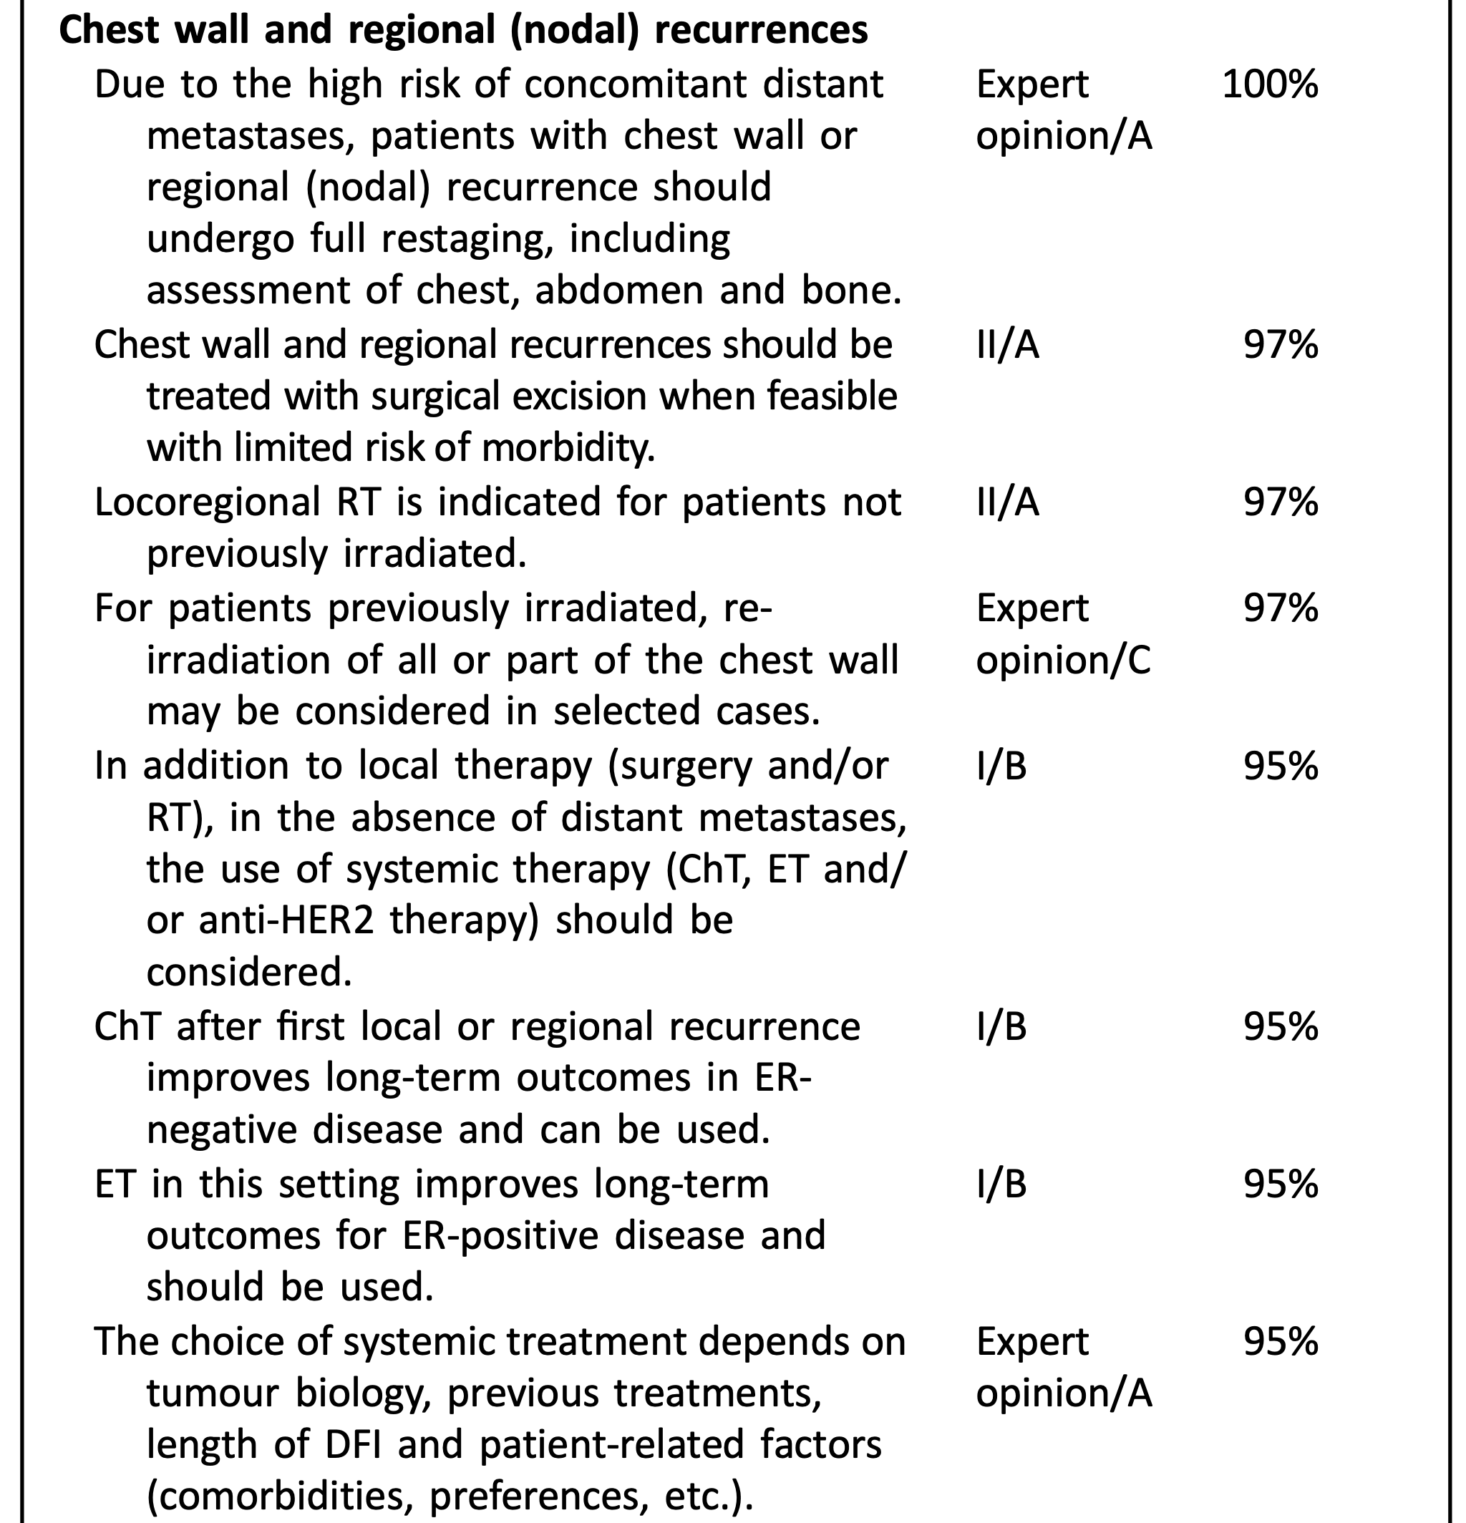
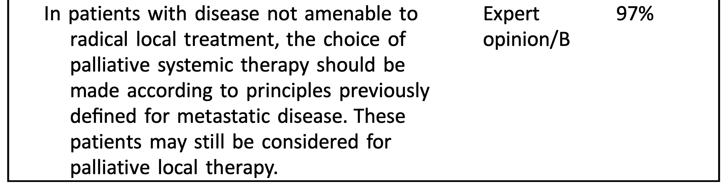
Skin, Benign disease, Palliative Oncology – 國泰吳錦榕主任

Question 1 Metastatic cancer 🡪 RT alone? Role of palliative RT?
Patchell et al. RCT (2005 Lancet oncol)，在患者有metastatic epidural spinal cord compression (MESCC)的情形下，建議OP+RT 🡪 able to walk after treatment, walk longer and regained the ability to walk than RT alone; need for corticosteroids and opioid analgesics was significantly reduced in the surgical group
Temel et al. (2010 NEJM) NSCLC, early palliative care 🡪 significant improvements in both quality of life and mood; compared with standard care, early palliative care = less aggressive care at the end of life but longer survival!
ENABLE III RCT (2015 JCO) Early vs. 3 months delayed palliative care 🡪 equivalent patient reported outcomes and resource utilization, but 1y OS improved!
- 207 pts with oncologist determined prognosis of 6-14 months
- 1y OS 48→ 63% with early palliative care (好像有問這個比例?)
- Palliative condition很多，常見有brain, bone, spinal cord, organ specific (lung/liver/SVC/obstruction/bleeding…)等等，每個情境下又有個別文章探討各種治療間在不同end points下的差異。值得留意的是，當systematic treatments進展到能夠延長overall survival的時候，如果RT能夠受惠於技術上面的進步，利用SBRT讓local control達到不單單只是symptomatic relief，而是能達到ablative dose，同時也不會中斷病人太多systematic treatments的時間，我想這是未來治療的趨勢，甚至能夠跟SABR-COMET一樣有OS benefit

Question 2 良性病灶做過什麼，做法為何(自由發揮)?
因為有一keloids情境題，放上keloids介紹
- Keloids = Benign fibroblastic growth with RF including surgery, burns, trauma, foreign body rxn, and occasionally spontaneous.
- Hypertrophic scars do not extend beyond the margins of scar.
- RT Timing: Deliver within 24h (2d) after surgery. Same day preferred due to repopulation of fibroblasts [Luo PRS '01]
- BED10 >30 → Recurrence rate < 10%. Recurrence after surgery alone > 50% [Kal SUO '05, Flickinger IJROBP '11].
- Old dogma: 12/3 (16.8 Gy-10) with LC 73% [Kovalic IJROBP '89].
- RT dose: Aim for BED2 >60 Gy (e.g., 20/5) [Renz IJROBP ‘18, Flickinger IJROBP '11] or BED10 >30 [Kal SUO '05].
- 21/3 for most locations (35.7 Gy-10), 18/3 if on earlobe (28.8 Gy-10) [Flickinger IJROBP '11]. (這個18/3 on earlobe我們做過，本來有VS擔心如此高fraction size軟骨會necrosis，目前f/u半年還好持續追蹤中)
- Also 16/2 (28.8 Gy-10), 19-11/1 (13 Gy in 1 fx is ~30 Gy-10).
- Definitive RT 37.5/5, 1.5y significant regression in 97%, 63% very happy with outcome [Malaker Clin Onc '04].
- Standard recurrence rate 20% if PORT, up to 40% for definitive [Mankowski APS '17].
- Sclafani [Derm Surg '96]: PORT vs. intralesional steroids with LR 12.5→ 33%.
- Scar + 1.0-1.5 cm margin.
- Other options include steroid injections, cryotherapy, pulsed-dye laser, pressure earrings, interferon, topical agents.
- Retreatment with lower energy electrons, kV photons, or BT.
Question 2.1 30 y/o female未婚單身未生育，Keloid長在肚臍下，你怎麼給她建議?
UpToDate建議The clinician should discuss with the patient his/her needs, concerns, and expectations. Patients with keloids should be informed that there is a high recurrence risk associated with all treatment options and that repeated treatments or multiple treatment combinations may be necessary to achieve satisfactory results…
其實除了手術與RT，還有其他治療選擇，例如intralesional corticosteroids, intralesional fluorouracil, silicone gel sheets, pressure therapy, cryotherapy, laser therapy, other intralesional agents (bleomycin, mitomycin, and topical imiquimod cream)，要評估患者keloid情況再做治療建議，如果會顧忌位置與年紀還有2nd malignancy，RT可以放比較後面的順位。不過基本上照射都是使用電子射線，如果可以在非病灶區再加上鉛皮保護與選擇適當的能量與bolus使用，相信可以讓周遭組織接受到的劑量降到很低。如此表淺的劑量基本上對於肚子裡面的器官(卵巢)基本上是不需要擔心的。當然治療前還是要確定病人沒有懷孕啦！(吳主任有解釋2nd malignancy機率大約是萬分之三，當然也是有文獻在討論這種因果關係，causation cannot be confirmed in these cases, caution should still be used when prescribing adjuvant radiation therapy for keloids, particularly when treating younger patients…)

Question 3 Skin cancer RT indication
ASTRO Guidelines for SqCC and BCC [Likhacheva PRO '19]: (我覺得蠻像SCCNH的)
See HNCIG Consensus Guidelines for PORT in complex cutaneous SqCC of the H&N [Porceddu IJROBP '20]
- PORT recommended for gross PNI that is clinically or radiologically apparent.
- PORT is recommended for close/positive margins which cannot be corrected with further surgery, especially for SqCC.
- PORT is recommended in the setting of recurrence after a prior margin-negative resection, especially for SqCC.
- PORT is recommended for T3+ SqCC.
- PORT is recommended for desmoplastic or infiltrative SqCC in the setting of chronic immunosuppression.
- PORT is conditionally recommended for BCC involving bone or infiltrating into muscle.
- Regional nodes may be omitted in the setting of LND and a single, small (< 3 cm) cervical lymph node without ENE.
- Use caution with SLNB for tumors after extensive primary resection/reconstruction and tumors in H&N area.
- SqCC at high risk of regional nodes (thickness > 6 mm) is conditionally recommended if the primary site overlaps the nodal basin.
Dose
Adjuvant RT after LND should receive 60-66 Gy, while ENI is generally acceptable with 50/25 (2 Gy) or 54/30 (1.8 Gy).
Definitive RT: Conventional BED10 70-93.5. Hypofractionated (2.1-5 Gy/fx) BED10 56-88.
PORT: Conventional BED10 59.5-79.2. Hypofractionated (2.1-5 Gy/fx) BED10 56-70.2.
In patients with resected locally advanced SqCC, the addition of concurrent carboplatin is not recommended.
** In patients with unresected LASqCC, the addition of concurrent drug therapies is conditionally recommended. **
BCC/SqCC | < 2 cm | >2 cm, >6mm DOI, T3-4 | Adjuvant | Regional SqCC
Conventional | 60-64 Gy | 60-70 Gy (cartilage) | 60-64 Gy | 50-60 Gy if SM-  60-66 Gy if SM+ or ECE  50/25 if cN0, at risk  60-70 Gy for cN+
Hypofractionation | 55/20, 50/15 | 60/24, 55/20, 45/15 | 50/20
 | 40/10
 | 30/5 biw

Cutaneous Melanoma
NCCN suggests patients who meet Burmeister criteria may be considered for adjuvant RT.
- TROG 02.01 [Burmeister Lancet '12, Henderson '15]: Palpable LND ± ISRT 48/20 in pts with HR criteria.
Adjuvant RT for cN+ lymph nodes has small improvements in regional relapse but no confirmed benefit for DM or OS. RT is likely appropriate for patients with high risk of regional recurrence, such as ECE. It may be reasonable to advocate for RT if ECE or high nodal burden, but otherwise consider observing (esp if LE) due to lymphedema risk and high risk of distant failure. Adjuvant RT after LND is NCCN category 2B.
- In the modern era, immunotherapy, BRAFi, and observation are reasonable treatment options as well.
- Other factors include ECE, thick lesions > 4 mm esp if ulcerated or with satellitosis, and SLNB(+) without completion dissection.
- In the context of (+)SLNB, there appears to be no DMFS, CSS or OS advantage with completion LND [MSLT II, DeCOG].
Melanoma | Definitive | Adjuvant | Regional | Palliative
Conventional | 64-70 Gy | 60-66 Gy | 50-66 Gy | 30/10
Moderate hypofrac | 50-57.5/20-23 | 48-50/20 | 48-50/20 | 50/20
Ultrahypofractionation | 35/5 if < 3 cm  32/4 q1w | 30/5 | 30/5  24-27/3 | 20-30/5

Question 4 癌症診療品質認證條文3-3是什麼?
110年度癌症診療品質認證 基準及評分說明【曾通過認證醫院適用版】
癌症防治醫療機構應針對晚期癌症病人建立緩和醫療之照護標準與流程
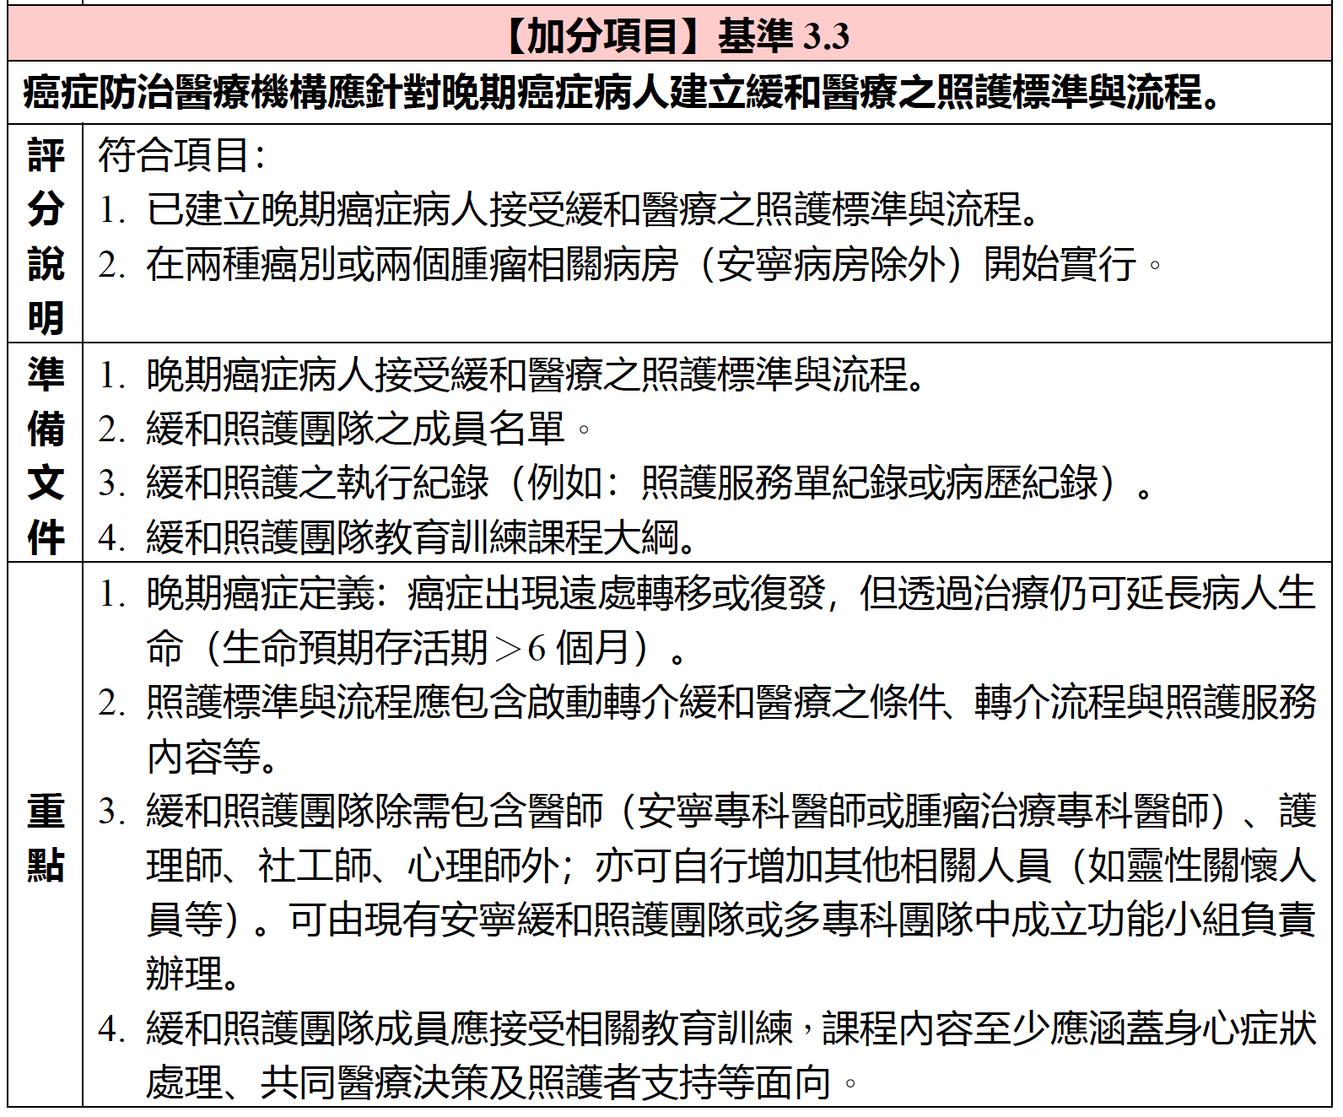

推薦加入癌症安寧緩和學會！

